Refraction W.S.
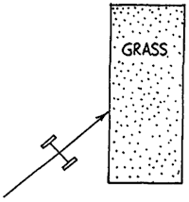
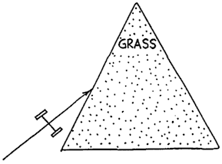
Refer to the following information for the next two questions.

A pair of toy cart wheels are rolled obliquely from a smooth surface onto two plots of grass - a rectangular plot as shown at the left, and a triangular plot as shown at the right. The ground is on a slight incline so that after slowing down in the grass, the wheels speed up again when emerging on the smooth surface.

Discuss with your partner the path and direction of travel for each cart. You need to finish each sketch on a sheet of paper. Be sure to show the orientation of the wheels inside the plots and on the other side.

- Describe the cart's path through the rectangular plot.

- Describe the cart's path through the triangular plot.

Refer to the following information for the next question:

Red, green, and blue rays of light are incident upon a glass prism as shown below. The average speed of red light in the glass is less than in air, so the red ray is refracted. When if emerges into the air it regains its original speed and travels in the direction shown. Green light takes longer to get through the glass.
Because of its slower speed it is refracted as shown. Blue light travel even slower in glass.

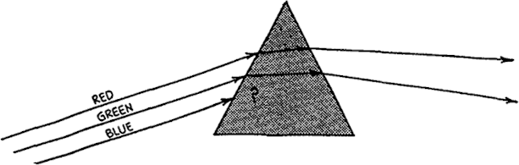
- Discuss the path and direction of travel of the blue ray:

Refer to the following information for the next question:
Below we consider a prism-shaped hole in a piece of glass—that is, and “air prism”.
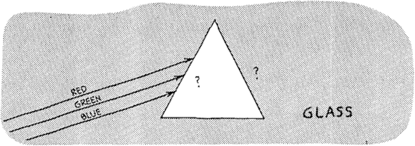
- Discuss the path and direction of travel of the beams of red, green, and blue light as they pass through this "prism" and back into the glass.

Refer to the following information for the next question:
Light of different colors diverges when emerging from a prism. Newton showed that with a second prism he could make the diverging beams become parallel again.

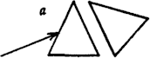
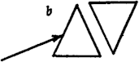
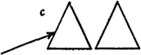
- Which placement of the second prism will do this?

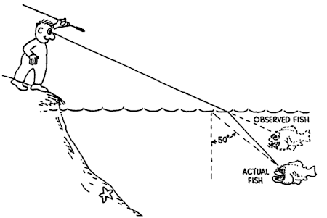
Refer to the following information for the next four questions.

The sketch shows that due to refraction, the man sees the fish closer to the water surface than it actually is.

- Discuss the direction a ray beginning at the fish's eye would follow to show the fish's line of sight when it looks upward at 50° to the normal at the water surface. The critical angle for a water-air interface is 48º.

- At the 50° angle, does the fish see the man, or does it see the reflected view of the starfish at the bottom of the pond? Explain.

- To see the man, should the fish look higher or lower than the 50° path?

higher | lower

- If the fish's eye were barely above the water surface, it would see the world above in a 180° view, horizon to horizon. The fish-eye view of the world above as seen beneath the water, however, is very different. Due to the 48° critical angle of water, the fish sees a normally 180° horizon-to-horizon view compressed within an angle of .

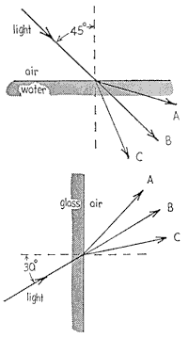
- The sketch given on the left shows a light ray moving from air into water, at 45º to the normal. Which of the three rays indicated with capital letters is most likely the light ray that continues inside the water?

A | B | C

- The sketch given on the left shows a light ray moving from glass into air, at 30º to the normal. Which of the three is most likely the light ray that continues in the air?

A | B | C

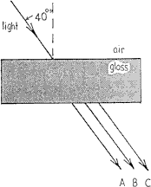
- On the left, a light ray is shown moving from air into a glass block, at 40º to the normal. Which of the three rays is most likely the light ray that travels in the air after emerging from the opposite side of the block? On a sheet of notebook paper, show your partner the actual path the light would take inside the glass.

A | B | C

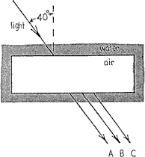
- On the left, a light ray is shown moving from water into a rectangular block of air (inside a thin-walled plastic box), at 40º to the normal. Which of the three rays Is most likely the light ray that continues into the water on the opposite side of the block? On a sheet of notebook paper, show your partner the actual path the light would take inside the air.

A | B | C

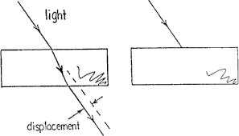
- The two transparent blocks are made of different materials. The speed of light in the left block is greater than the speed of light in the right block. On a sheet of notebook paper, show your partner the an appropriate light path through and beyond the right block. Is the light that emerges displaced more or less than light emerging from the left block?

more | less | stays the same

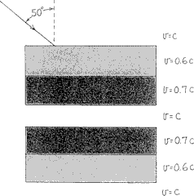
- Light from the air passes through plates of glass and plastic below. The speeds of light in the different materials is shown (these different speeds are often implied by the "Index of refraction" of the material). On a sheet of notebook paper, show your partner a rough sketch showing an appropriate path through the system of four plates. Compared to the 50º incident ray at the top, what can you say about the angles of the ray in the air between and below the block pairs?

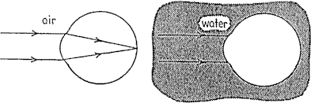
- Parallel rays of light are refracted as they change speed in passing from air into the eye. Below, show a rough sketch showing appropriate light paths when parallel light under water meets the same eye. Do the rays still come to a focus on the retina of the eye? Explain.

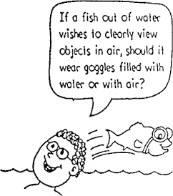

- Why do we need to wear a face mask or goggles to see clearly when under water?

Directions: For each True or False question, place the answer to each question in the textbox provided. If you decide that the statement as given is false, in addition to entering FALSE in the textbox, you must ALSO provide a correction to the second part of the original statement so that it will become a true fact.

Although you may "submit answers for grading" as often as you like to check your answers as you complete the worksheet, only your initial answer to each question will count towards your final score. So be careful.

True or False. (provide a correction if the statement is false)

- The value for the index of refraction, n, of an optically dense medium is allowed to fall anywhere in the range between 0 < n < 1.

True or False. (provide a correction if the statement is false)

- The speed of light in a vacuum is 3 x 108 m/sec.

True or False. (provide a correction if the statement is false)

- The average speed of light while traveling through a medium whose optical index of refraction is 1.5 would be 2 x 108 m/sec.

True or False. (provide a correction if the statement is false)

- A ray of orange light of wavelength 600 nm is 6.00 x 10-7 meters long.

True or False. (provide a correction if the statement is false)

- The frequency of orange light of wavelength 600 nm while traveling in air would be 2 x 1013 hz.

True or False. (provide a correction if the statement is false)

- While a ray of orange light (whose wavelength is 600 nm in air) is traveling through a medium whose optical index of refraction is 1.5, its wavelength would be 900 nm.

True or False. (provide a correction if the statement is false)

- The frequency of orange light (whose wavelength is 600 nm in air) while traveling through a medium whose optical index of refraction is 1.5 would be 7.5 x 1014 hz.

- Summary: Mark each statement that is TRUE when light enters an optically denser medium.

its average speed decreases,
its wavelength decreases
its frequency decreases
the angle of refraction in the new medium is less than the angle of incidence in the initial medium

Diagram Questions

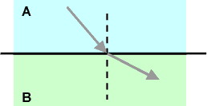
- According to the diagram shown above, which substance, A or B, is the more optically dense medium?

A | B

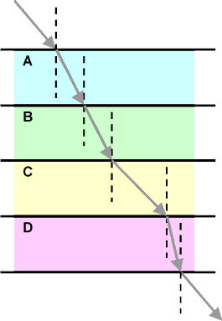
- According to the diagram shown to the right, which statement is false?

nA = nB
nB > nC
nC < nD
nD > nA
nB > nD
the light exits and enters from the same medium

- Which diagram shown below correctly illustrates the path of a monochromatic ray of light through a triangular piece of glass?
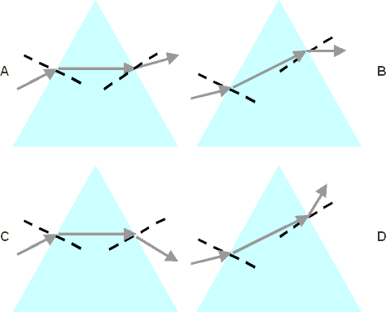

A | B | C | D

- Which diagram shown below correctly shows the path of a light beam passing through a rectangular "air bubble" in a piece of glass?
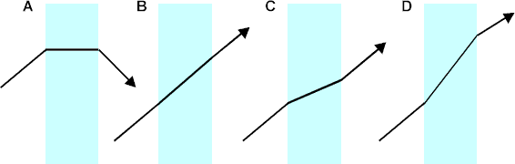

A | B | C | D

- What is the wavelength of green light, λ = 500 nm in a vacuum, while it is traveling through a diamond, n = 2.4?

125 nm | 208 nm | 407.6 nm | 1200 nm

31.. What is the frequency of the green light in question #1?

1.4 x 1015 hz | 1.7 x 1014 hz | 2.1 x 1015 hz | 6 x 1014 hz

- When white light passes through a triangular prism, which color is least deviated - that is, which color travels the fastest through glass?

green | orange | red | violet | yellow

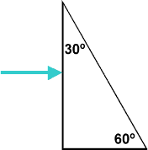
- If the index of refraction for green light in glass is 1.510 and for violet light is 1.523, what is the angular dispersion between the rays of these two wavelengths when emerge from the prism shown below? (Draw a diagram showing how the light travels through the prism.)

0.5712º | 0.755º | 0.7615º

- What is the critical angle if light traveling in glass (n = 1.5) is submerged in water (n = 1.33)?

62.5 º | 48.8º | 41.8º | no critical angle exits for this combination

- If the external medium remains constant, as a substance's index of refraction increases, the critical angle decreases.

True | False

- Which of the following does NOT occur when light enters a less optically dense medium?

its wavelength lengthens
its frequency increases
its average speed increases
if it enters the medium obliquely, the angle of refraction is greater than its angle of incidence - it bends away form the normal

- Light can no longer escape from an optically dense medium into air once it reaches an angle of incidence within the medium equal to or greater than 30º. What is the index of refraction for this medium?

2.7 | 2.0 | 1.9 | 1.7

- In an optical fiber, light actually
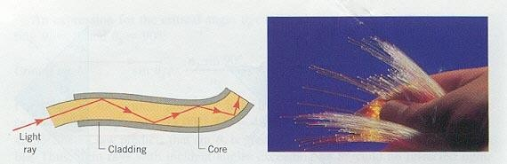
image courtesy of
Dr. Joseph Alward, University of the Pacific

curves in a direct parallel to the central axis of the fiber
travels in straight line segments between bounces
travels along the outer surface of the fiber causing it to glow
any of the above could happen depending on the type of fiber being utilized

- Atmospheric refraction would make the total amount of daylight time available a bit
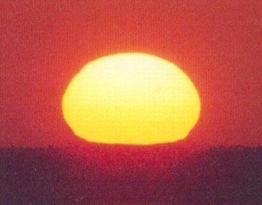
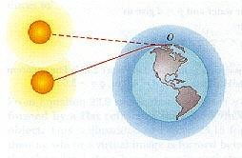
images courtesy of
Dr. Joseph Alward, University of the Pacific

longer
shorter
longer in the summer but shorter in the winter

- A mirage is a result of atmospheric
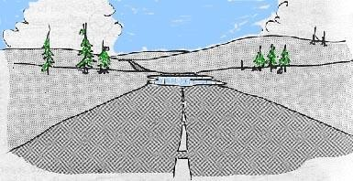
image courtesy of
Dr. Joseph Alward, University of the Pacific

aberration | reflection | refraction | resonance | scattering

- Which of the following does NOT contribute to the formation of a rainbow?
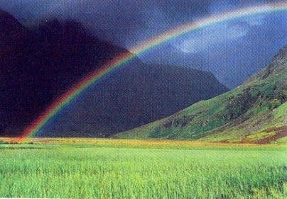
image courtesy of
Dr. Joseph Alward, University of the Pacific

light is internally reflected in the water drops
there is destructive interference between the reflections off the front and back surface of the rain drops causing only one color to be seen from each drop
light is dispersed during refraction while exiting from the water drops
the sun must be behind you at the same time that the raindrops are in front of you
the sky is bright under each rainbow where thousands of overlapping rainbows combine to form a "white glow"

- True or False. In order for a person to view a rainbow, he only needs one raindrop since every raindrop disperses all of the colors in the spectrum.

True | False

- The critical angle for a transparent medium is the minimum angle at which all light within the material is totally internally

refracted | reflected | absorbed | dispersed | diffused

- Refraction causes the bottom of a swimming pool to appear

shallower than it physically is
deeper than it physically is

- When viewed from above, how deep would a coin resting in the bottom of a pan of water 20 cm deep, appear be?
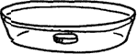

25 cm | 20 cm | 15 cm | 10 cm | 5 cm

- When light enters an optically denser medium, how is the wavelength of the light affected?

- Is there refraction for incident angles of ? (Explain)
(a) 0⁰
(b) 90⁰
- Explain how refraction causes the pencil in the figure below to appear almost severed.
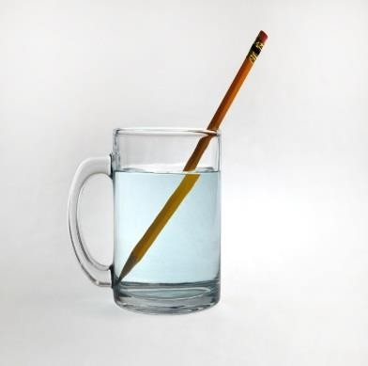
- Does atmospheric refraction have any affect on the length of the day? That is, would the daylight hours be longer or shorter if we had no atmosphere? Explain.

- A root-beer mug looks as though it holds more than it actually does because the liquid appears to be closer to the sides than it actually is. Explain this “optical illusion” that makes you think that you’re getting more for your money. (Hint: refer to the image below and explain)
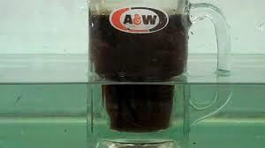

- Is it possible to have total internal reflection with light in air incident on water? Explain.
- Consider light in air incident on a glass surface. What is the maximum angle of refraction that can be achieved? (Hint: Think of reverse-ray tracing)
- We sometimes say that total internal reflection can be used to make an internal “mirror.” Would it be possible to see an image in such an internal mirror? Explain.
- Why is a spectrum of colors not seen when light passes through a glass windowpane?
- A prism can be used to separate white light into a spectrum of colors. Could another prism be used to recombine the spectrum colors into white light? Explain.
- Is there an absence of rainbows after some rains, or is there always a rainbow and an observer may not be in the proper location to see it? Explain. (Rains after dark are excluded)
- Why are rainbows seen in the form of “bows” or circular arcs? Why is the secondary rainbow fainter than the primary rainbow?
- Do two observers at different locations see the exact same rainbow? Explain your answer.

- With dispersion and a single internal reflection in a water droplet, it might appear that the red arc of the primary rainbow would be below the violet or blue arc. However, the colors of the primary rainbow are seen to run vertically from violet to red. Explain why this is the case. Hint: Refer to diagrams below:
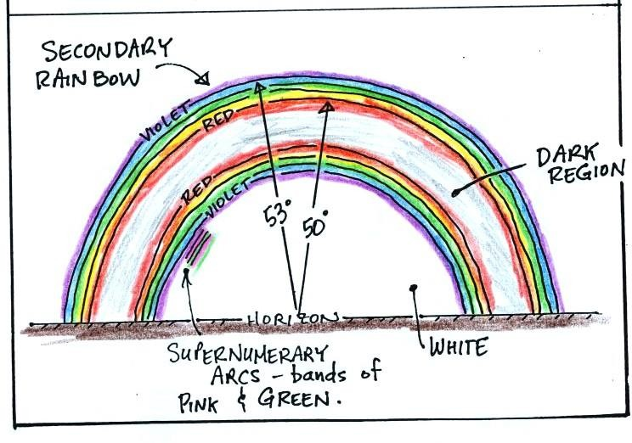
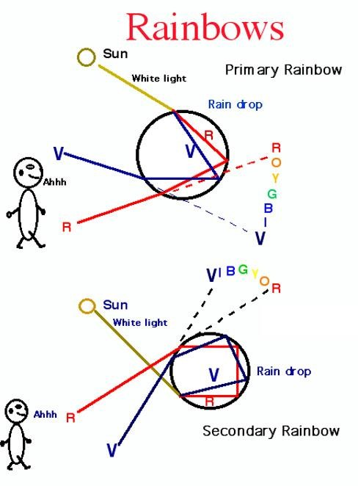

- A halo or ring is sometimes seen around the moon or Sun as a result of high thin cirrus clouds that are composed of ice crystals. What causes these halos? (Hint: Keep in mind that the clouds are between the light source and the observer.)

